|  |
| --- |
| Printervalley.com |
| Prusa I3 Build manual |
| Build your own 3d-printer! |

|  |
| --- |
| Marco van Noord  12/4/2013 |

Contents

Introduction 2

Necessary tools 3

wooden frame 4

Y-axis 5

Printbed holder 9

Print bed 11

X-axis 12

Z-axis 13

Top 14

z-tensioner 14

Hot end 15

Endstops 18

Electronics 19

Power 19

Motor wires 19

Connecting all the bits 20

Finishing up the electronics 21

Reference pictures 22

Connecting your printer 25

Useful notes 25

# Introduction

Thank you for purchasing the Prusa i3 from Printervalley.com.

With the help of this manual, you can build your own 3d-printer in about 1-2 days time, depending on your mechanical skills and knowledge.

# Necessary tools

Since this printer comes as a kit, you will need a couple of tools to build it all together. The most important tool, a 2mm hex wrench, is in your box with parts. The other tools you might need are:  
  
 - socket wrench 13

* Monkey wrench
* Soldering iron
* Flat screwdriver
* (Stanley) knife
* 3mm drill
* Sandpaper
* Ruler/measuring tape
* Patience

Before we start, it’s a good idea to lay out all the parts on a table and to examine them carefully, so you will have a general understanding which parts are supposed to serve which goal.

I would advise you to read the whole manual first before starting.

Some general tips:

* Try to use washers where you can. They distribute forces on either plastic or wood, which will prevent them from breaking.
* Since all parts are printed, it is possible some holes aren’t big enough. You can use a small file, some sand paper, a drill or a rod which has been held above a flame to make things fit.

# wooden frame

We will first put the wooden frame together.

First, grab the big square frame. This is the centerpiece of your printer.

Now, take the two large triangular pieces, and examine them. One of them has all kinds of holes in them. This will be the left side of the printer

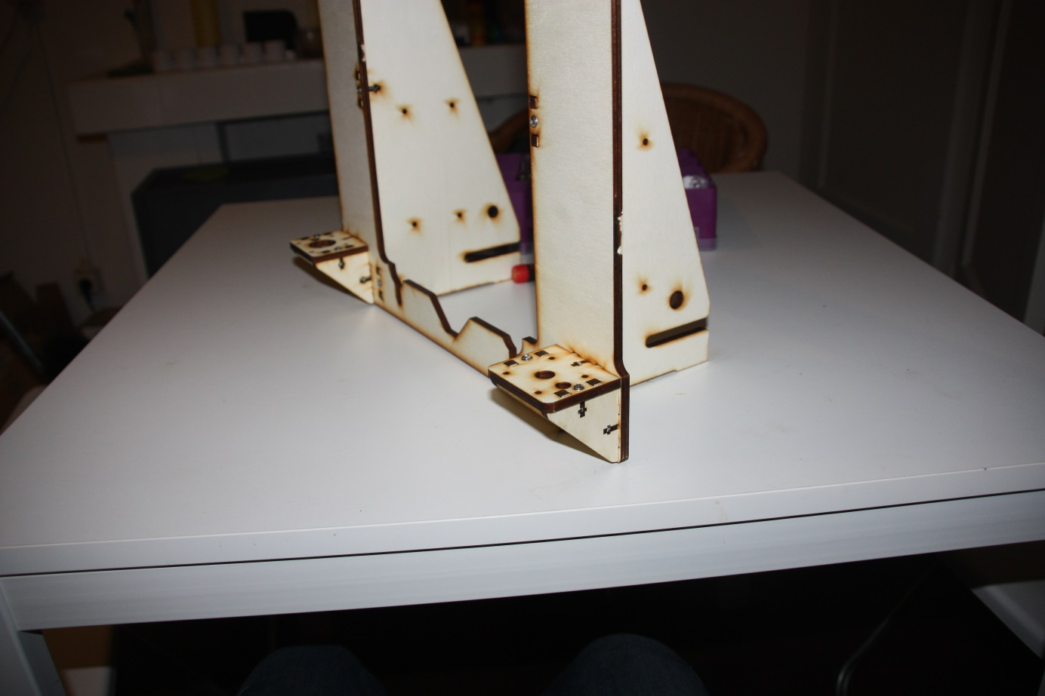Now take both parts, and put them in the designated slots in your square frame. Not that the frame doesn’t have a left or right, so you cannot really do this wrong. Put a nut in the 6 t-slots and fix them with a 16mm M3 bolt with a washer.

Next, take the four triangle wooden parts and their accompanying square counterparts. Mount them as in the picture, taking care that the one with the bigger hole is on the left side.

Your wooden frame is now mostly done.

# Y-axis

The y-asis is your table that slides forth and back. It will be made of some pieces of steel, held back together with the 4 printed corners.

First, take the longest pieces of M8 rod (38cm) and 35cm, 8mm smooth rod. They should be about 38cm long. Take some nuts, the four printed corners and three lm8uu linear bearings and put it together like in the following configuration. Use some sand paper or a file to get rid of any sharp edges on the ends of the rods, as so not to damage the bearings. Don’t over tighten things, just tighten everything by hand.

Note that the part with only one bearing will become on your printers left side, which is seen with the triangles sticking to the back.

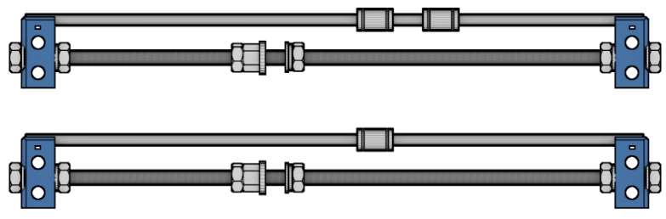

Now, we take the three remaining short rods and the longer rod, together with the motor mount (the part with 4 holes), the y-idler, and put it together like this:  
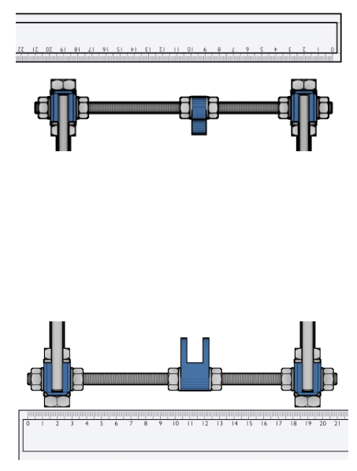

All rods should be the same, except for the back top rod. That should be the longer rod. This is what will give the printer most of its stability.

Now we will take the last wooden part and test-fit it on the linear bearings. Don’t attach things yet, since it will make assembly a bit harder, but see if it fits nicely on those bearings. Slide it up and down to see if the left and right rods are perfectly parallel. Adjust them if necessary.

Next, we can put the x-axis in the wooden frame. Put a nut and a ring on either side of the longer rod and slide it between the slots in the triangle parts. Now slide the lower rods in the main frame. Measure it (see image) and tighten them carefully. Having a 90 degree angle is very important, so be sure to check that too.

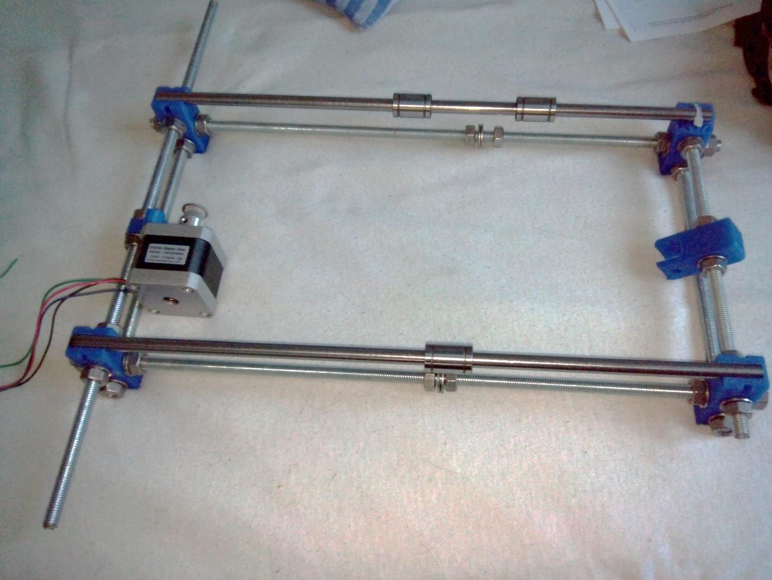

You can now tighten all the nuts a bit more with a 13mm wench, but be sure to take care so not to break the plastic parts.

Note that the image has the linear bearings switched, and that it’s missing the longer rod in the back.

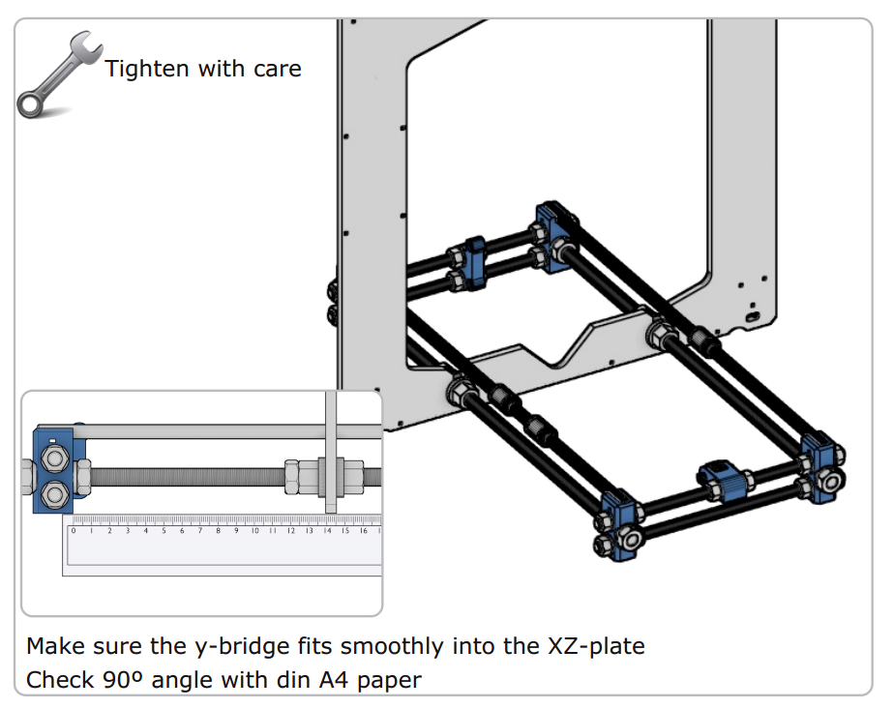

# Printbed holder

Now that the y-axis is done, we can put the printbed in place. First, we put a pulley on the motor and then we fix the motor to its mount, with the motor facing to the LEFT.

It’s now time to take two of the 624 bearings and put in the idler with a 30mm screw. These two bearings will guide the y-belt.

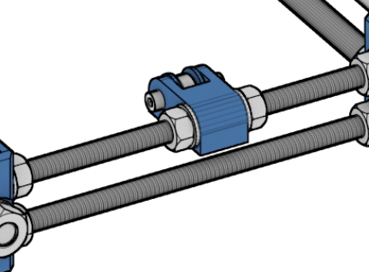

It’s time to fix the belt holder to the underside of the wooden printbed. Make sure to put the nuts in the designated nut trap.

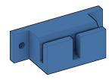

Next, grab the printbed and put it on top of the linear bearings.

Now grab the y-belt, and put it through the idler and over the pulley. Be sure that the idler and motor line up with the belt holder. If not, you might experience some increased wear on the belt, so adjust those so they are perfectly in line.

Now everything is in place, you can fix the bed to the bearings with the zip ties. Be sure to put the end of the zip tie on the underside of the bed. Pull them tight and clip the endings.

Now slide the belt into one slot of the belt holder and tighten it with zip ties. Make sure to leave enough length to do this with the other side.

It might be possible that due to differences in printed parts, the ribbed side of the belt holder isn’t close enough to the belt, so the belt slips away. You can solve this by putting some m3 washers between the top (smooth side) of the belt and the belt holder.

Now one side is done, you check that the belt isn’t twisted and fix the other end of the belt like below. Make sure that the belt is relatively tight. Now your y-axis is done, and you should already see your printer taking shape!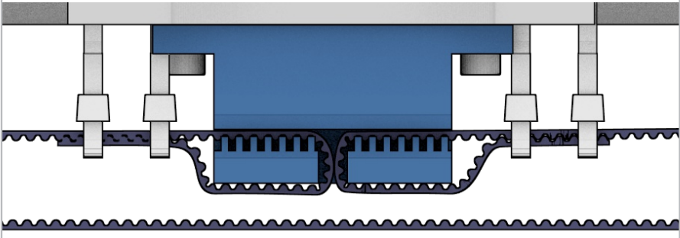

# Print bed

We are going to put the acrylic print bed on the wooden bed.

We do this by taking 3 20mm screws and put a washer on them.

Now, put them through the acrylic. Get the three bed springs and push them on the screw, the small side first. It might need some minor adjustment to the springs to make them fit.

Next, comes the tricky part. It’s best to lay the printer on its side for this, or have someone help you.

Put the bedscrews through the wooden bed part, and fix it together with a nut. Be sure not to tighten them, just make sure the nut doesn’t fall of; we will later on adjust everything.

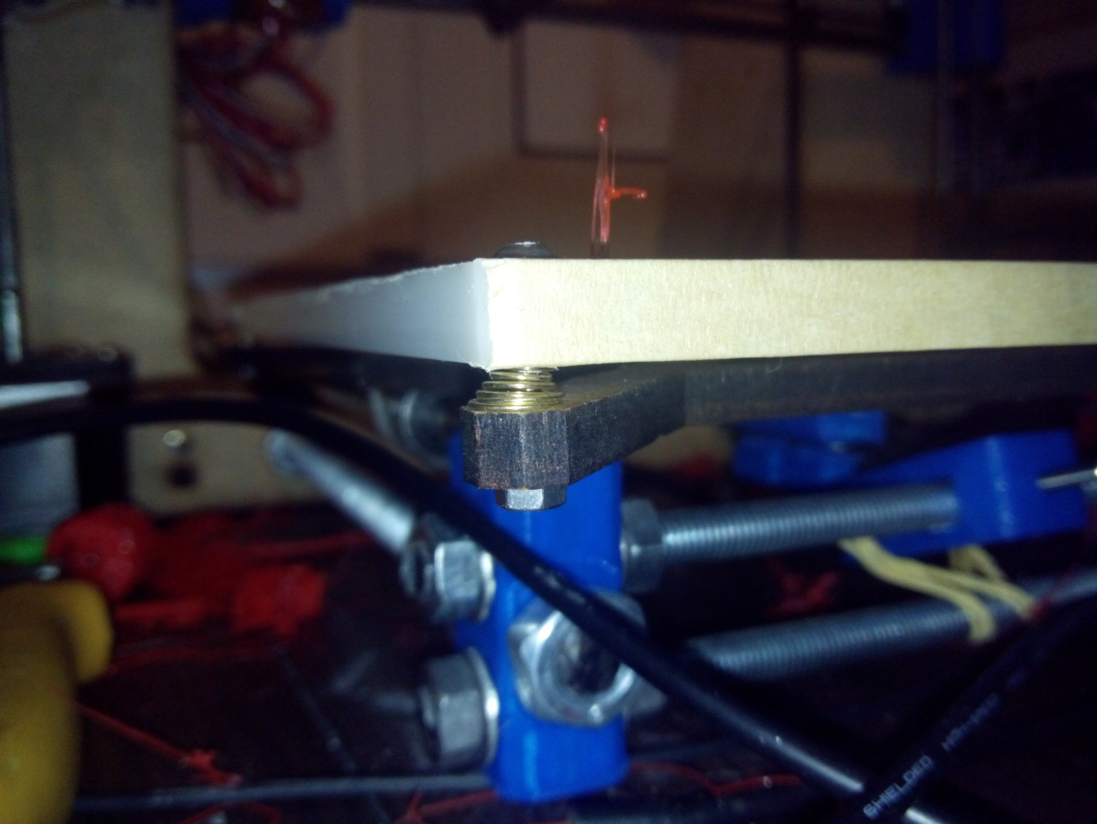

# D:\Dropbox\Projects\supermaker\Manual\x-ends.pngX-axis

The x-axis is the part that slides left and right, carrying the hot-end and the extruder drive.

We start by taking the x-motor part and x-idler.

We take four lm8uu linear bearings and press them into their designated area.

They are designed to sit very snugly, so it might take some effort to get them in. A flat screwdriver to open up the hole a bit might be necessary, just be careful not to break it.

Insert two M5 nuts into their nut trap.

Now get a 608 bearing (the biggest ones) and fix it with a 30mm screw. Be sure to put the nut on the same side as the M5 nut. It might be a smart idea to use some washers to make sure the bearing sits nicely in the middle between its sides.

Now get those 37cm long smooth rods, and put one linear bearing on one of them, and two on the other. Use some sand paper or a file to get rid of any sharp edges on the ends of the rods, as so not to damage the bearings.

We can now push the rods into the ends. The rod with two bearings goes on top, the other one on the bottom. The ends are made to be push-fit, so with some force, you can get them in, and there’s no need to fix them. If you really can’t get them on, carefully use a 8mm drill to open up the holes. There should be 30,5cm of rod between the two ends. 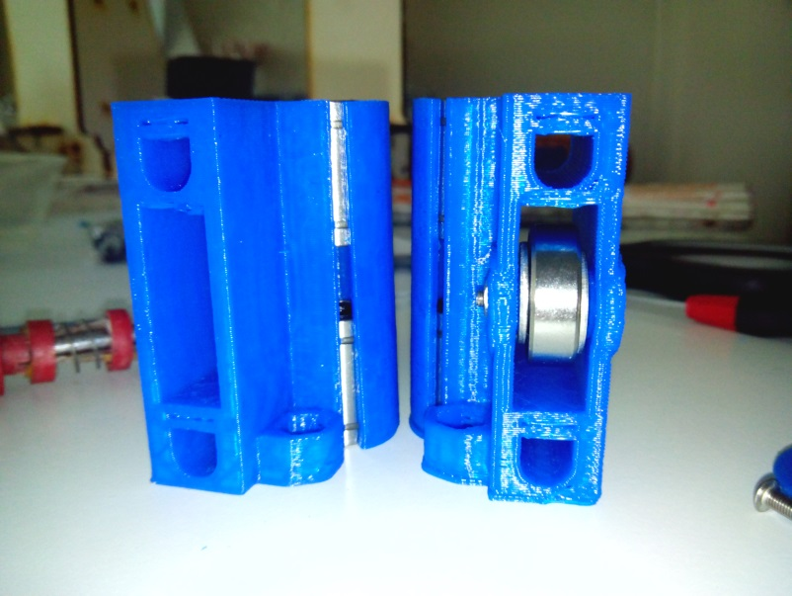

Now, we can put the x-axis aside, while continuing with the Z-axis

# Z-axis

First, grab one of the motors, and fix it on the left side in the motor holder. Fix it with some 10mm screws with a washer.

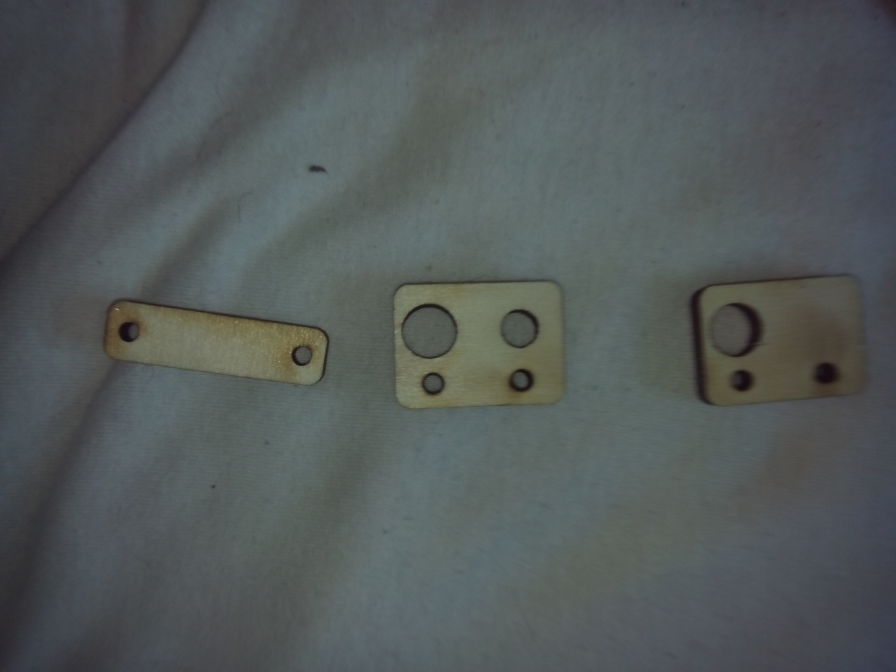

Figuur : wooden part

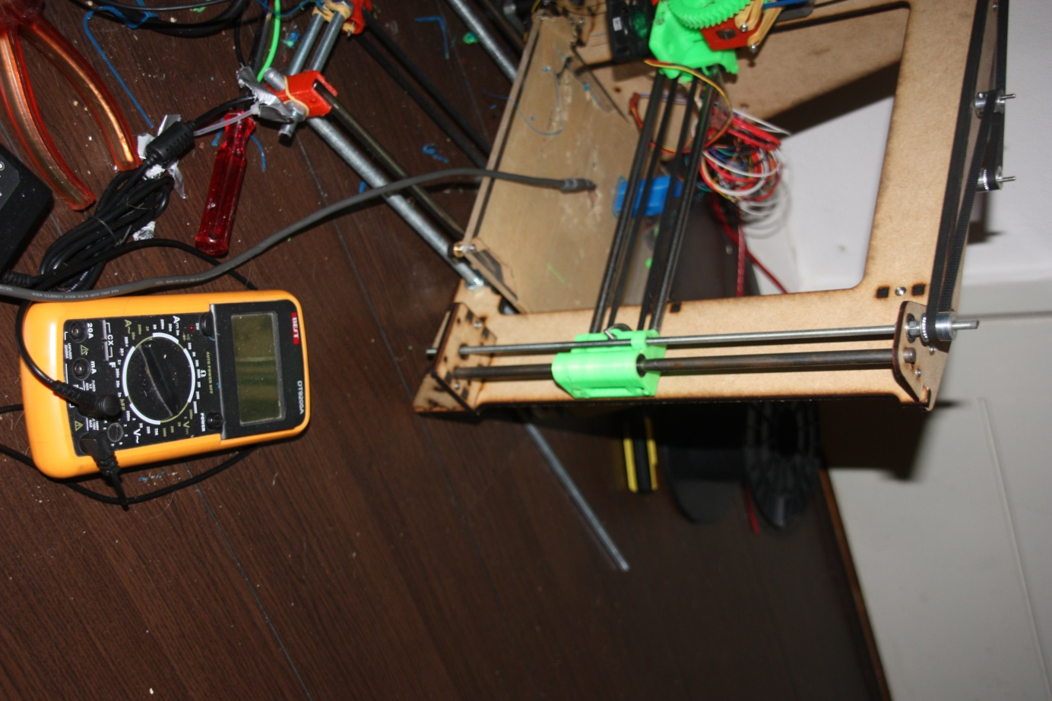On the right side, on the underside of the mount, fix the wooden part.

This will later on prevent the smooth rod from falling out.

Now take the smooth rods, use some sandpaper to deburr the ends so that the inside of the bearings won’t be damaged. The bearings are easily damaged, after which the balls will fall out.

Get the clear aquarium tubing, and cut it to 4cm length.

Now, heat it up a bit, with your hands or a hairdryer, to make it a bit softer.

Push it on the motor shaft. Get the short 5mm rod and screw it through the motor-end. After that, push and turn it into the aquarium tubing, just like below. Make sure that you leave approximately 1-2mm between the motor shaft and the threaded rod.

Get a 5mm M5 nut and screw it all the way on the left rod.

Get the x-assembly with the rods and put them through their slots in both of the motor mounts. The left should lean on the motor, while the other leans on the wooden part you just installed. The 5mm rod you mounted on top of the motor should go through the nut-holder in the motor-end of the x-axis. It should rest on the nut you screwed on.

Next, it’s time to put the x-axis on the smooth rods. Just let it rest on the bottom. Meanwhile, get the 5mm threaded rods. Make sure that you put the longer one on the right side. Also, don’t forget to double-check if the 5mm nuts are in the nut traps of the motor-end and the idler.

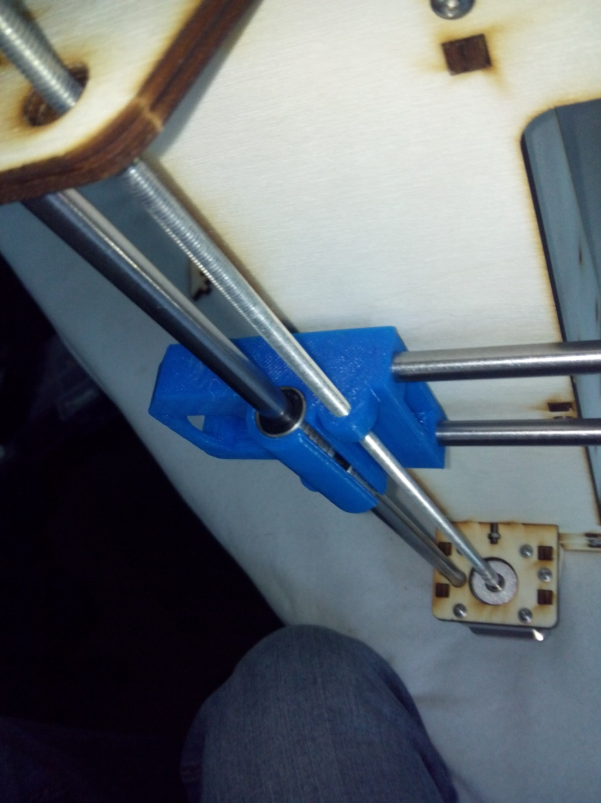Screw the long threaded rod into the idler-end.

# Top

Next part is to grab the two top-z-parts and put a z-axis bearing (605zz) in both of them. They should be able to fit, with a bit of force. They only fit from once side.

Now, screw a M5 nut on both of the rods, and then place the wooden parts on the printer, putting the M5 rods through the bearings. Fix the wooden parts to the frame with some m3 16mm screws. Make sure both z-smooth rods go through the holes, as shown in the pictures.

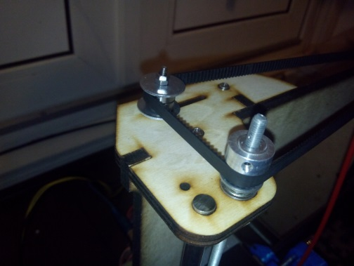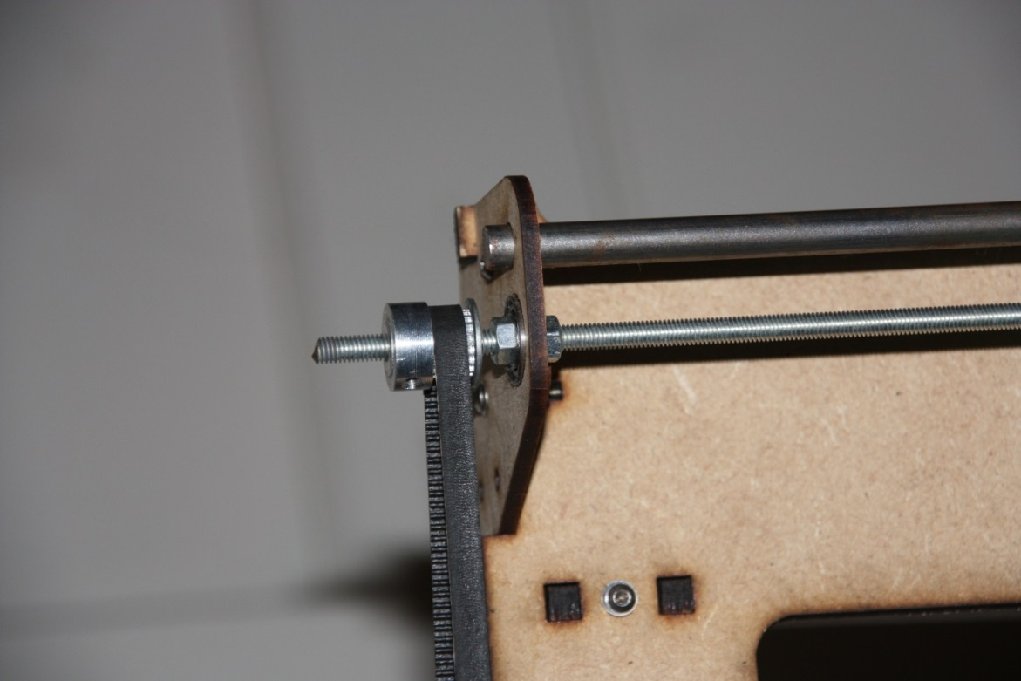

Screw the 5mm nuts a bit back, so it touches the bearing, and put another one on top of the bearing.

Screw both nuts tightly towards each other, fixing it to the bearing. Pay attention not to bend the left wooden part.

The last two pulleys should go on top of the threaded rods. The thick part of the pulley goes on top. Don’t screw the pulley tight yet, since we need to level the z-axis first.

### z-tensioner

To tension the z-belt, we need a m3 30mm screw, some washers, a few nuts and the two huge rings.

Put the screw with a washer through the slot in the left wooden part, and put a washer and nut on the other side to hold it in place. Now on top of that goes: the big ring, a nut, the bearing, an m3 ring, the big washer and another nut. You should have something similar to this:

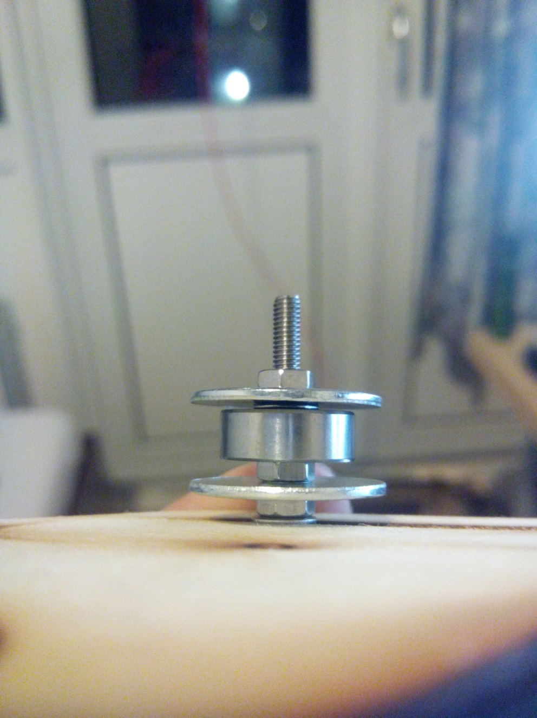

Now you can lay the z-belt around the pulley,pulley and tensioner. Slide the tensioner outwards, until you cannot push the belt together any more in the middle.

# Hot end

We start off by grabbing the idler hinge; see the image on the right. We grab one of the 608zz bearings, put the 8mm, 20mm long rod in it, and force it into its slot. This might require some force.

We now grab the cold end (that’s the biggest piece of plastic you have), and fix the idler on it with a screw and a nut, if necessary.

Grab the two other 608zz bearings, and push them in both sides of the 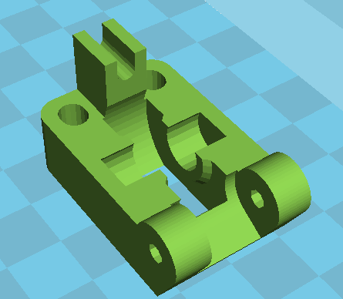cold-end.

You might need to remove some material, but make sure both bearings sit really tight in there.

Grab the Waynes hobbed bolt, that’s the M8 bolt with the weird cut in the middle, and put it through the large herringbone gear. Get 2-3 M8 washers, put them on the bolt and push the bolt through both of the cold-end. You might need some force. Putting a file flat on the screw to file a bit off is also fine. Just make sure not to damage the sharp teeth, that will eventually grab into the filament.

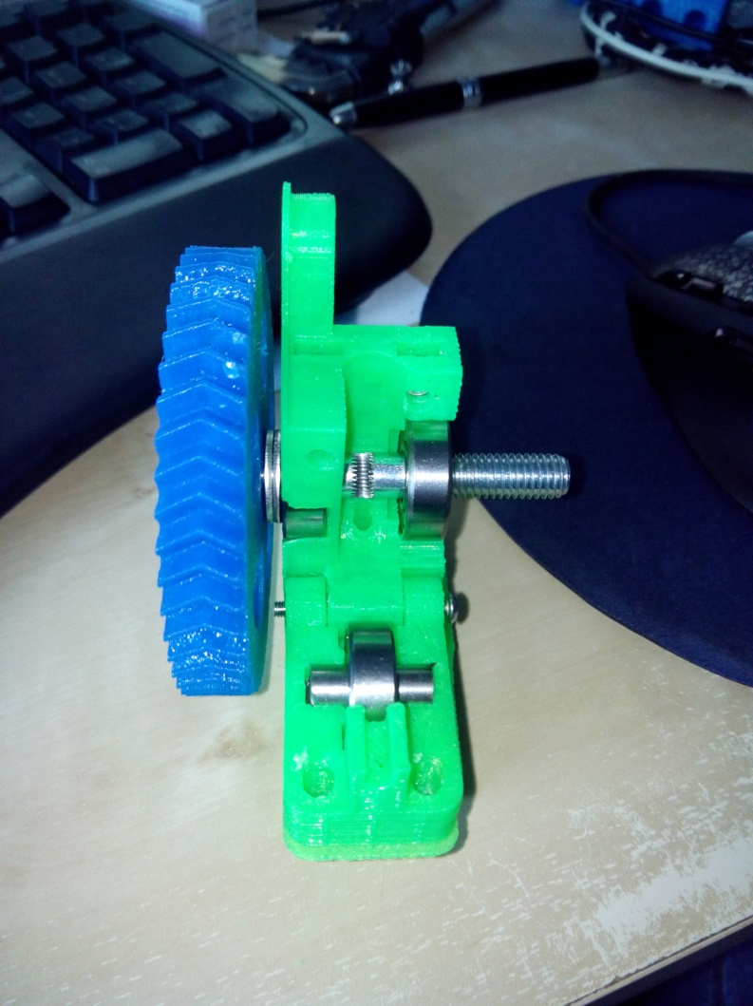Your cold-end should look somewhat like on the image on the right, except for the different gear. You also don’t need the M8 nut on the right.

Next, grab another motor and put the small herringbone on there. There’s only one way it will later grab into its big brother, so make sure not to put in on backwards. With a nut in the small gear and a 10mm screw you can make sure it won’t slip.

It’s time to mount the motor with the three mounting holes. Use a washer and the 10mm screws. Make sure the gears are touching, but not grinding.

Next is to grab the hot-end, it should fit into the underside of the cold-end. You can fix it with two 16mm screws. Make sure the hot-end is completely in, before fastening the screws, as not to break the PEEK (that black plasticky stuff on the hot end).

Make sure the wires are on the gear-side, and you can use a tie-wrap to fix them to the motormount, if you want. 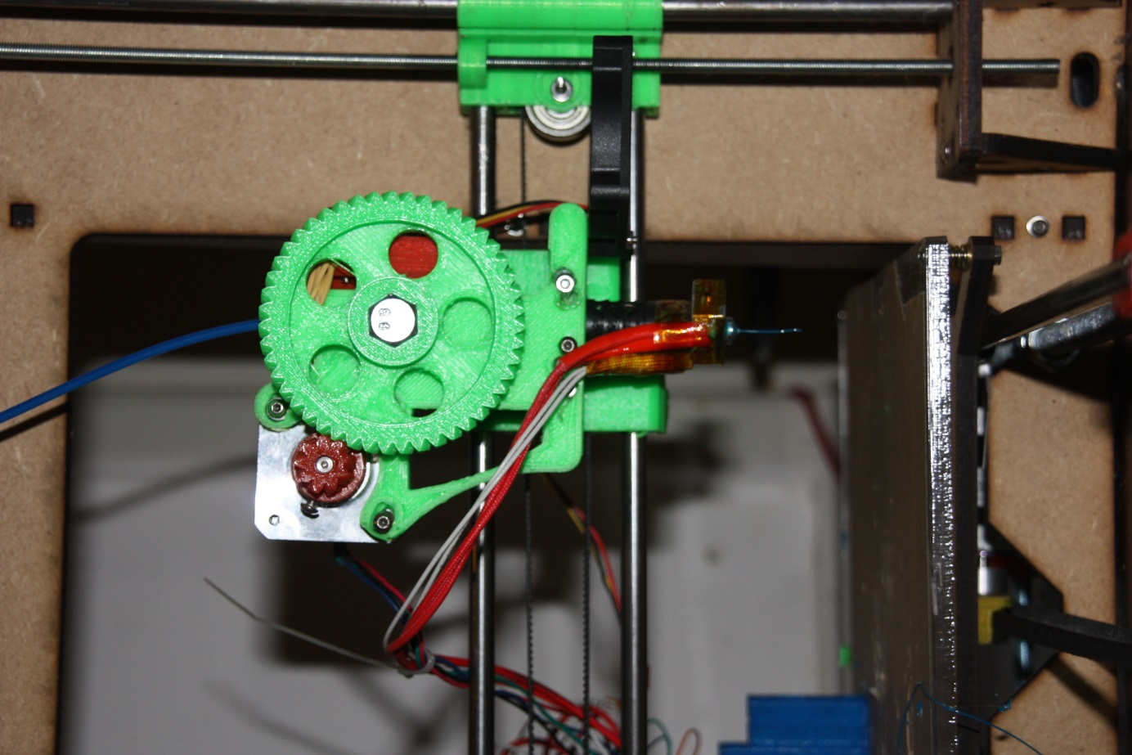

Now it’s time to grab two m4 nuts, and put them in the two slots on the top. Grab the two m4 screws put the two springs on there. It might be an idea to crimp the end that is touching the head of the nut, so it won’t fall off. Alternatively, you can use a washer of some kind.

Push the two bolts through the idler-hinge, all the way into their nut. By tightening, you can increase the amount of force the idler exerts on the filament, to prevent it from slipping, but we’ll do that later.

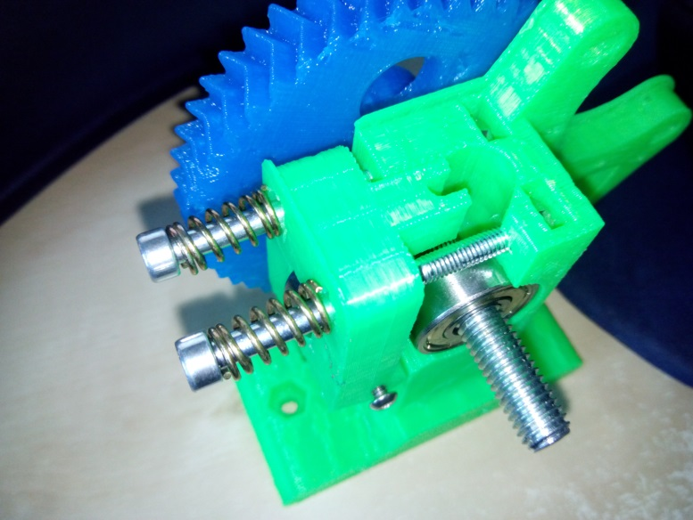

Next is to grab another two m4 screws and put them all the way through the cold-end, next to the holes where we just fixed the hot-end.

Now, grab the x-carriage, 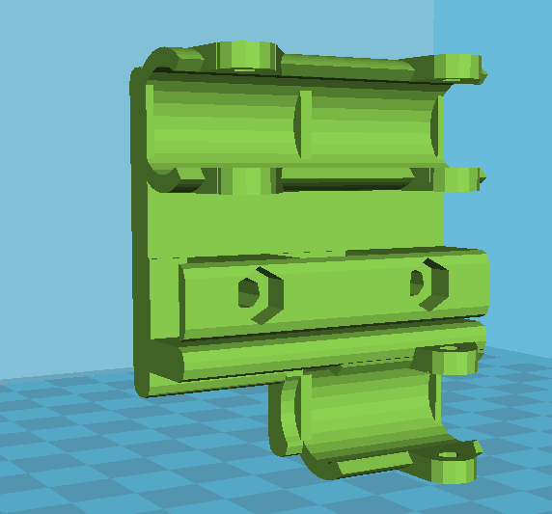and push it onto the linear bearings on the x-axis, but before doing that, put two m4 nuts in there, and make sure that the m4 bolts will fit through the hole.

The carriage should be sitting tightly onto the bearings. If not, you can use some tie wraps to fasten them, using the holes in the carriage.

Now, grab the cold-end, and screw it through the carriage, and straight through the nut. Make sure everything is tight to avoid any shaking later during printing. Refer to the image on the right-top to see how it should look now.

Now we grab the last motor, and put the last pulley on there. Make sure to put it on backwards: the pulley part first and the part with the locking nuts last. Don’t forget to tighten the locking nuts.

You can now mount the motor onto the motor-end with some 20mm screws. After that, it’s time to grab the x-belt. Get one end through the idler, and the other end over the pulley. The open end should be in the middle, at the bottom. We’re going to fix it in the carriage in the same way as with the y-axis. Put one end in the holder, and fix it with a tie wrap, put the other end in there pretty tight and fix it with a tie-wrap again.

We should now have a working x, y and (almost working) z- axis.

Now, grab a ruler, and measure the gap between the underside of the x-motorend and the motor holder. Now turn the right 5mm rod, to put it at the same level. Double check the x-axis to see if it’s completely level. If not, re-adjust until completely level. If your x-axis isn’t level, you will have a lot of problems with your first layer not sticking to the bed.

When you’re completely done, tighten the z-axis belt with the tensioners you made before. This way, your z-axis won’t go out of sync, thus leaving your x-axis parallel.

Now, we’re pretty much done with the mechanical part, congratulations if you made it this far. If you’re not this far yet, also congratulations, because it means that you’re reading the manual before starting.

# Endstops

Since we use stepper motors, we have no direct way of knowing the position of our bed and carriage.

To solve this problem, each time before a print starts, your motors will move towards their starting point, until it hits the endstop. It uses this to calibrate itself.

For the x and y axis, the position of the endstop isn’t very crucial, it just determines where on the bed your print will start.

However, your z-endstop is very important in getting your prints right. It determines the distance between your hot-end and bed on the first layer. If this is off by only 0,2mm, you can run into problems like the filament not sticking to the bed, or even worse: the hot end digging a grave in the printbed.

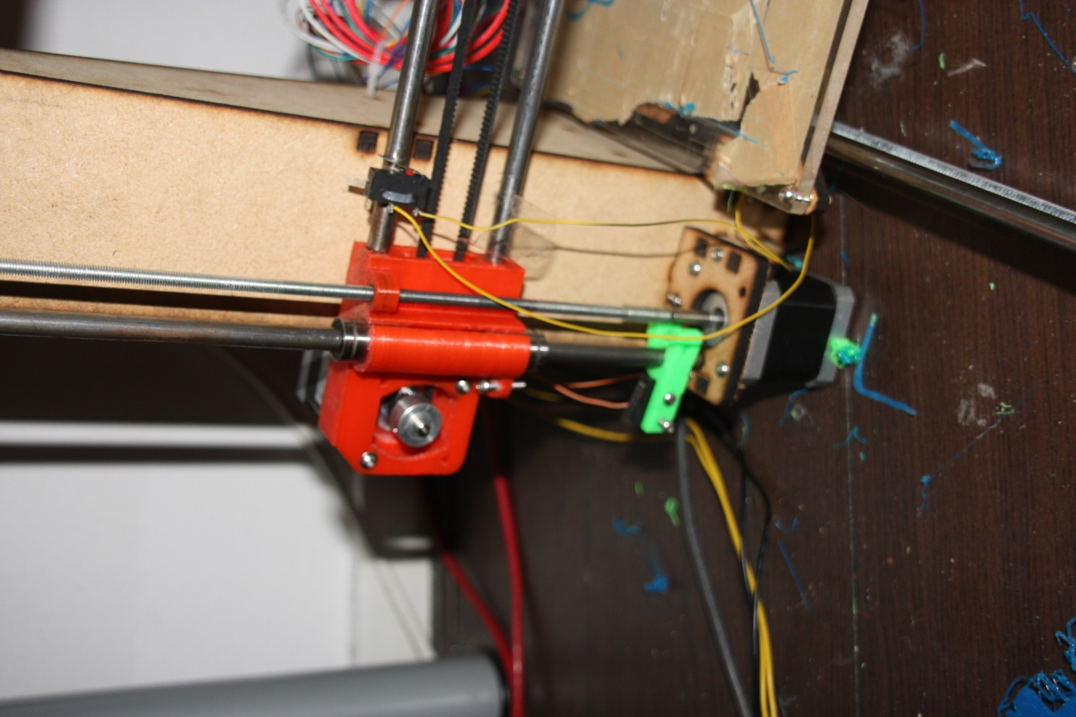For these reasons, we will need to make sure that the endstops are placed correctly.

Figuur 2: Z-axis with x- and x-endstops

First, we start by grabbing the three endstops, a soldering iron and the three 2-wired colored cables. Strip the end of them, and put a bit of tin on them.

Now, 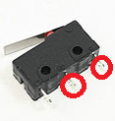solder the two wires to the points indicated in the image. Do this with all endstops.

We can now mount the x and y endstop directly to the frame. Grab a tie wrap, put it through the hole in the endstop, around the smooth rod and back through the endstop. Make sure you tighten it, so it won’t move later on.

The position of the x and z-endstop is seen in the image on the right. The y-endstop goes on the back, on the left smooth y-axis rod. Make sure the linear bearing of the bed touches the switch.

For the z-axis, grab the plastic endstop-holder that looks like the letter “h”. Using two 10mm screws, fix the z- endstop onto it, and push it onto the smooth rod, as seen on the image.

Grab a 20mm screw and put it in the x-motor mount, and screw it halfway through. Now lower the z-axis with your hands, making sure that the screw hits the endstop, the moment the hot-end touches the table. If the endstop-holder isn’t very tight, use a tie wrap or screw to hold it in place, using the holes that were printed in the endstop-holder.

# Electronics

Your 3d-printer is almost done. The only thing missing is the electronics that control all the motors, heater and read the endstops.

First, let’s take a look at the electronics board that came in the kit. It’s a minitronics 1.0 board. If you’re familiar with popular electronics, you might recognize the small black chip in the middle. It’s the same chip that’s in an Arduino.

Furthermore, we see a USB-B connection, which we also find on an Arduino and most USB-printers.

The small pins sticking out of the print are called headers, and it’s these headers that we will use later on to connect the motors, the temperature sensor, endstops and the cooler for the electronics board to.

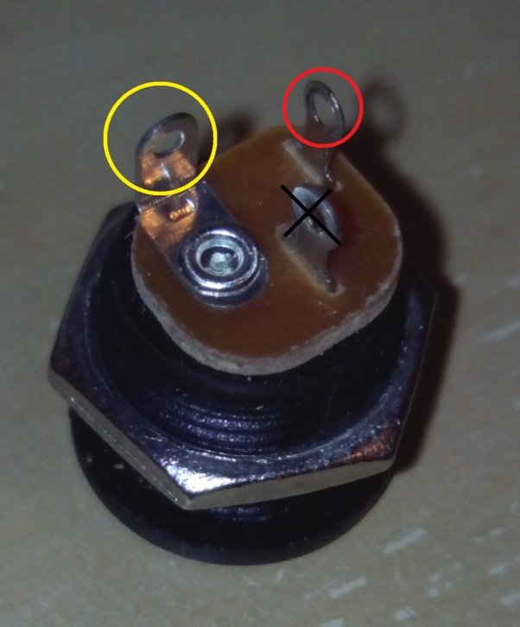The green things on the side of the board are called screw terminals. They are made for bigger currents than the headers. The heater in the hot-end can consume quite some power when heating up, so we definitely need these things. It also allows us to later on connect a heated print bed or a second extruder, if we want to upgrade our machine. They work by unscrewing that screw on top, then pushing a wire into the side and re-screwing the screw to make it clamp the wire.

Figuur 3: Solder a black wire to the red circle, a yellow one to the yellow circle.

Furthermore, there’s a white connector on the minitronics board. This is the power input. The power cable plugs into this, and has wires, two positive (yellow) and two negative(black).

## Power

We will start off by assembling the power cable. We grab the cable and strip the ends, so approx. 0,5cm of the bare conductor is exposed. We grab the two yellow wires, and twist those ends together. Make this connection permanent by soldering them together. Repeat this for the black wires.

Now, put the jack plug into the frame and lock it with the corresponding nut. The jack plug contains three connections. We will solder the yellow wire to the tab on the back of the jack plug. The black wire goes onto the other end of the jack plug. (It might be a smart idea to use some hot-glue or electrical tape to insulate the wires against shortcuts, or the accidental screwdriver touching the terminals.

The jack plug allows you to easily disconnect the power from the printer, may any problem arise.

## Motor wires

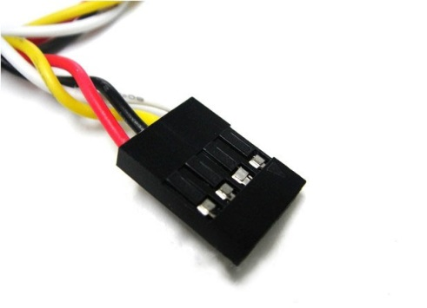All motors will need to have a solid connection to the board. To do this, we will solder some”4 pin dupont” wires to the motor wires. This way we can easily plug the headers onto the board.   
The wires coming from the motor are color-coded. The reason for this is because we use stepper-motors. Each time we put power on one of the wire pairs, the motor makes one step, exactly 1,8 degrees. This is the reason a 3d-printer is so accurate; we can carefully move the motors an exact amount.

Figuur : dupont wire

Just solder a dupont cable to each of the motor connections.

Make sure the cables are in the right order; the correct one is blue-red-green-black.

There should be 4 four-pin dupont cables in the kit, one longer than the rest. That one is for the extruder motor, since it needs some slack to be able to move.

## Connecting all the bits

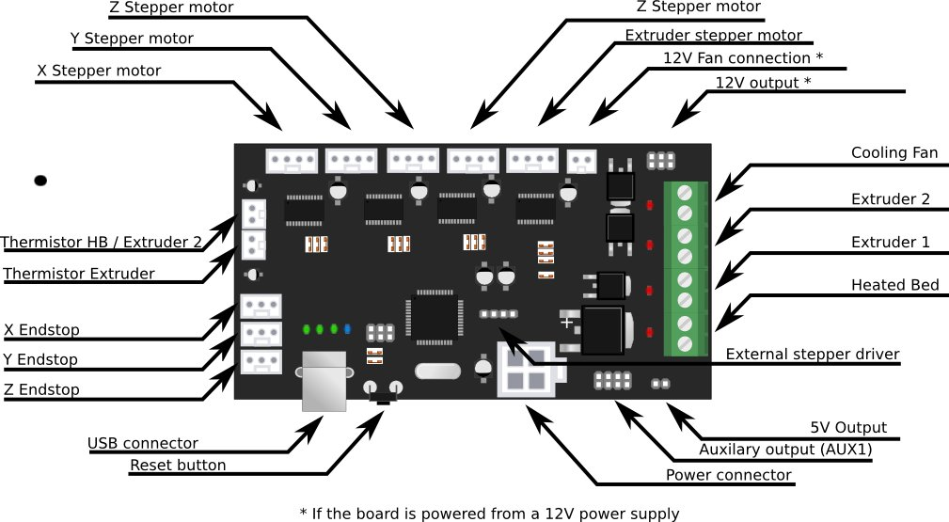

Figuur 5: All connections on the minitronics

Note: we hold the board with the usb-port towards us. The motor connections are on top, the endstop connections are on the left.

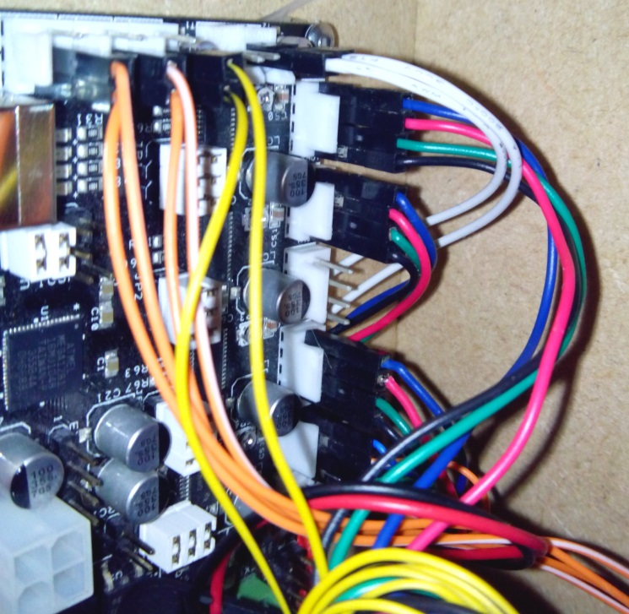Now that all wires are prepared, we can connect them to the board. If we look closely at the board, we can see that each set of headers has the name printed next to it.

Figuur : The endstops

We start off by grabbing the endstops. We connect the two pin header to the center and inner pin of the x, y and x-endstop header (so for each header, the pin closest to the edge of the board will remain unused). The endstops do not have any polarity, so there’s no possibility of putting them on backwards.

Figuur : Connect the motors

Next, we grab the wires of the motors. Like we told earlier, the wires of the motor are color-coded. We need to make sure that the wires are in the following order: blue-red-green-black.

We grab the connectors from the x, y, z and extruder motor, and connect them to the headers; the blue wire on the left ( see pictures). You might have noticed that there are two z-motor connections. It doesn’t matter to which we connect the motor since both are the same.

Next, we grab the two red hot-end heater wires. Strip them carefully and mount them under “extruder 1”, as shown on the picture.

Since we would like to know the temperature of our hot-end, we will connect the other two white wires coming from the hot-end to the header called “Thermistor HB/ Extruder 2”.

## Finishing up the electronics

Well done, you connected all the cables to the board.

You can mount the board at the side of the printer, and when you are sure that the printer works, you can use some tie wraps to do some cable management.

The only thing left to do is to connect the white power plug and a USB-B cable, both of which will fit only one way.

When the printer is running fine we will add two fans. The reason for this is so we can first focus on hearing all the sounds the printer makes, to get you familiar with them.

There’s a small fan, which we will mount on the minitronics to keep the stepper motor chips cool (just use some tie wraps to put it in place) and a slightly bigger fan we can mount on one of the two holes on the extruder mount. This way, it will cool your prints faster, which will result in being able to print faster. There are a lot of “fan mounts” on thingiverse to improve the airflow coming from that fan.

The small fan mounts on the “12v cooling fan” connection, red wire on the left, while the red and black wire of the bigger fan mounts to the top and bottom connection of the “cooler fan” connector.

# Reference pictures

Now, some pictures of my printer, so you will have an idea how yours should look like. Note that some parts on my printer are from an older version, so yours might be a bit different, especially the z-belt has had some revisions. 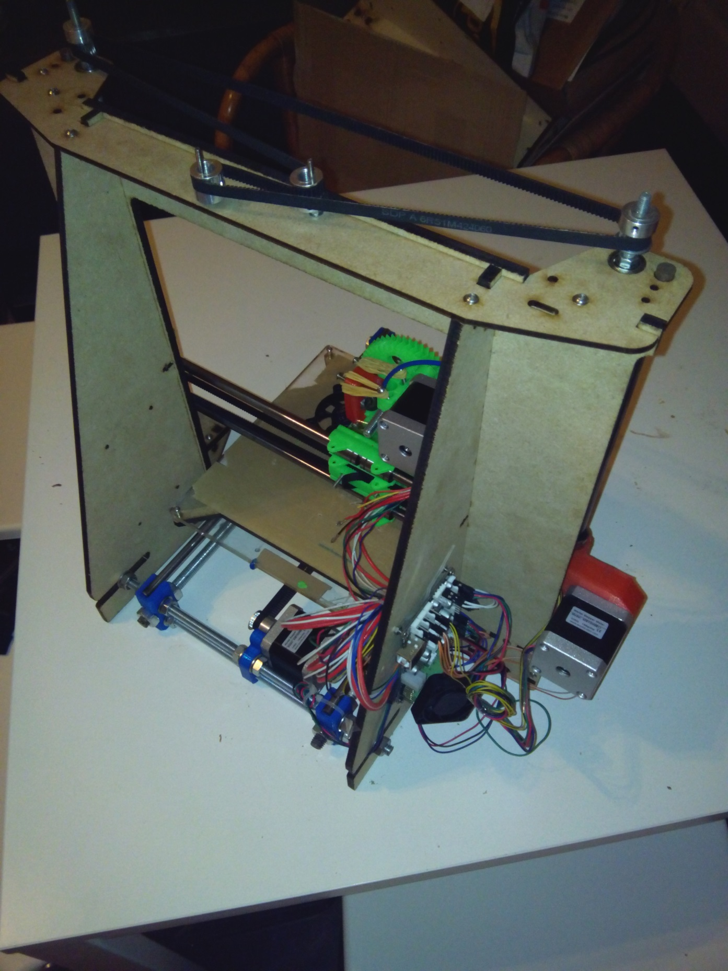

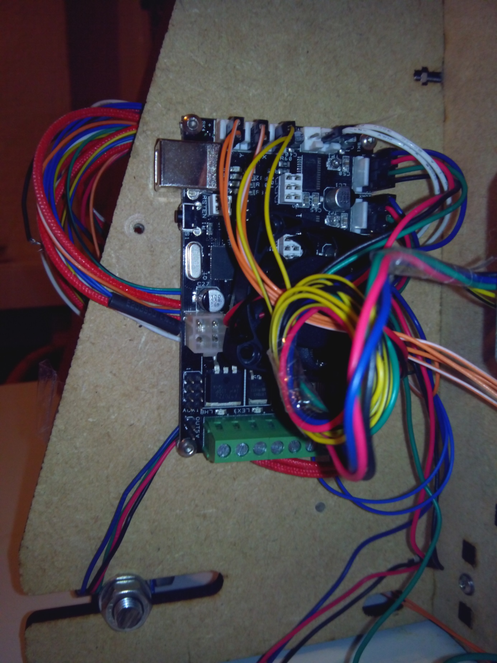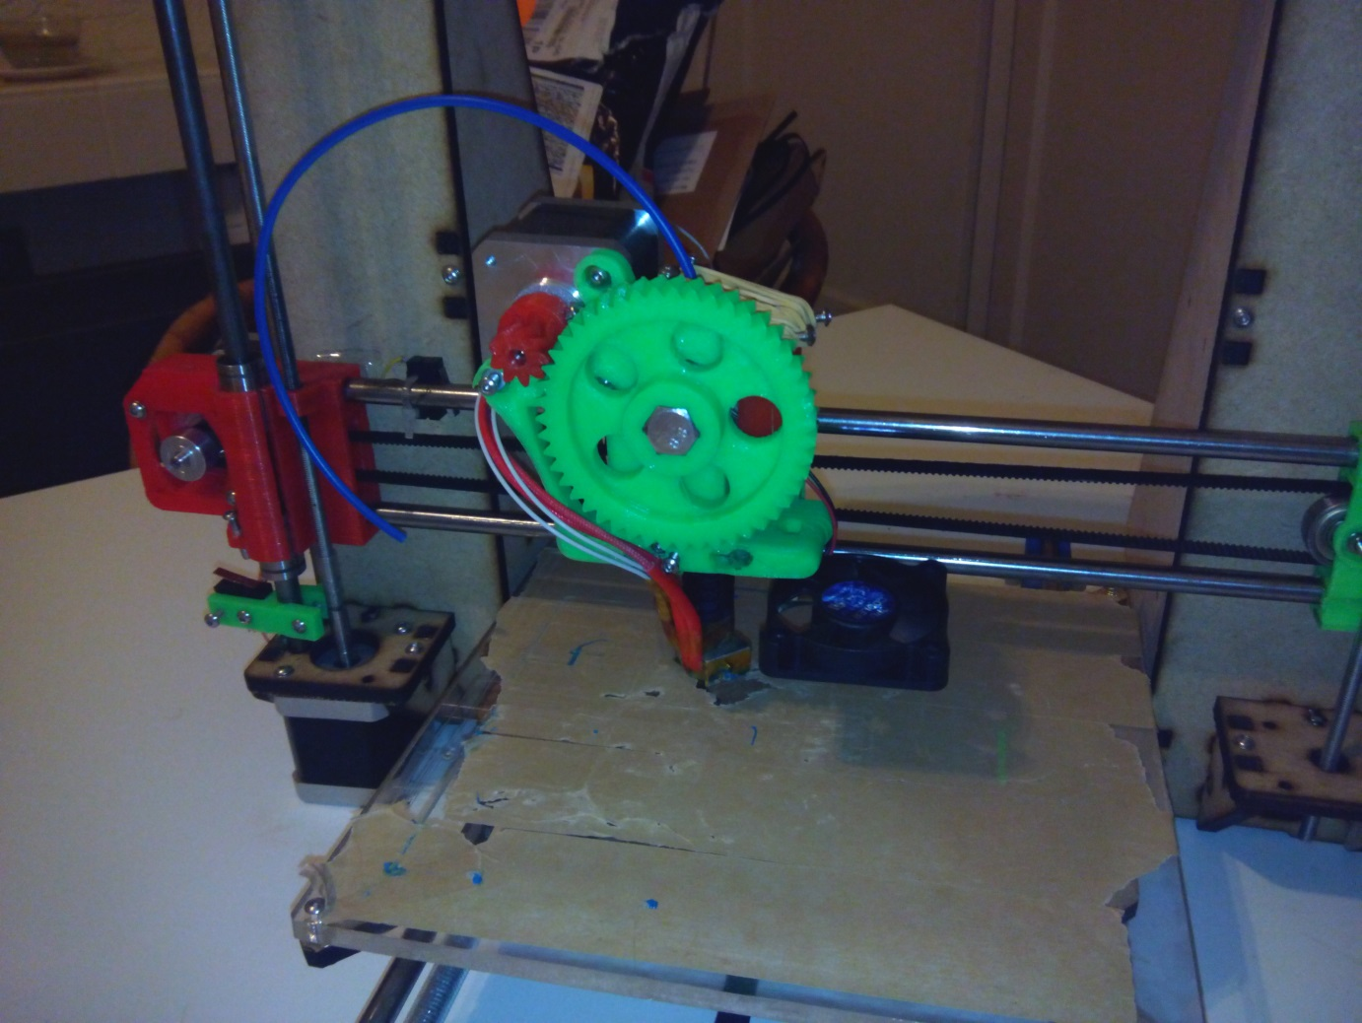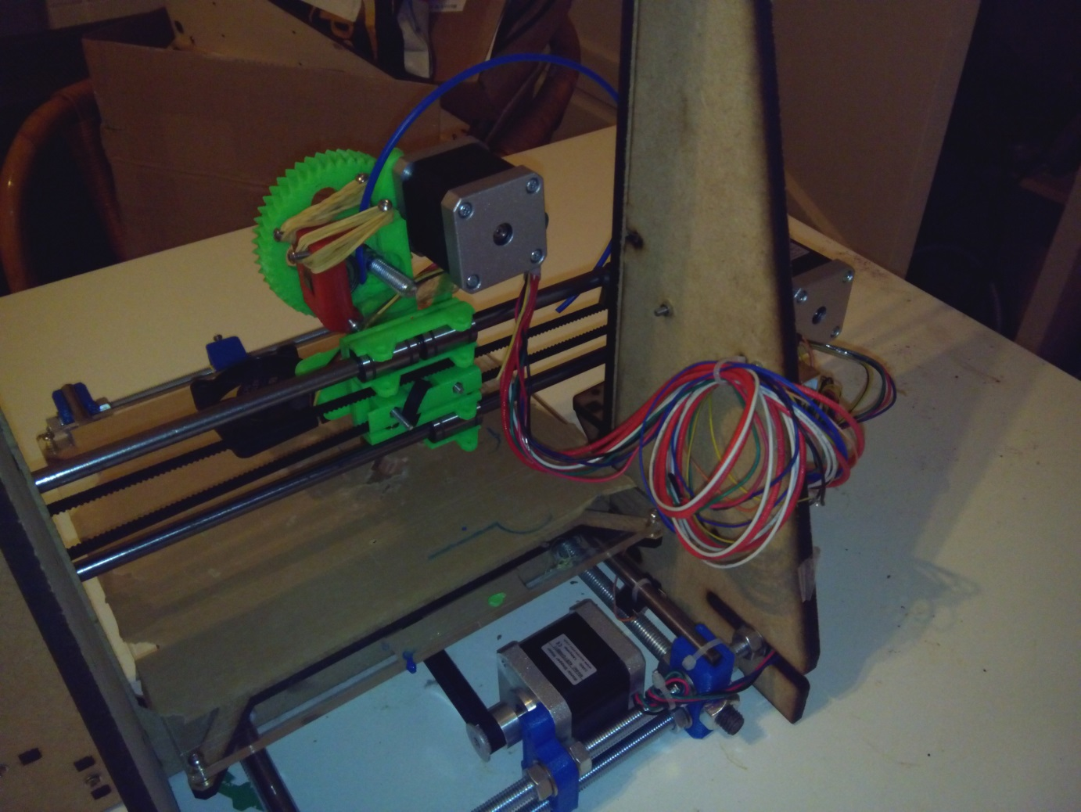

# Connecting your printer

In this chapter, your printer will finally come alive!

We first double check to see if everything is tight, nothing hanging loose. Double check the wiring to the motors, endstops and heater.

Connect the printer to your computer with USB, your computer should make a sound.

If you haven’t installed Cura yet, do so; since it will automatically install the correct drivers. If you start Cura for the first time, you will see a setup wizard. You can just close that, since it’s made for another printer. Now, we load a model into cura (a .stl file, for example from thingiverse.com) and press the print button at the top. We won’t look at any settings yet; first we want to check the printer. In the “printing” screen, it should say “connected”. If not, double check your wiring. Some lights should flash on your board.

Now it’s time to press print; no error should appear and another light should start blinking on the board; it’s trying to heat up. Just cancel the print, and let’s connect the power supply.

You might have to reconnect. Now go to the tab “jog” and push some of the buttons. Your printer should be alive!

On the main tab, increase the temperature of the hot-end, the temperature should start rising; to get the hot-end heated to 210, it takes about 2 minutes.

If everything works fine, you can start printing whatever you want!

You can find more information about Cura on <http://blog.ultimaker.com/cura-user-manual-full-settings/>

If you want to know more about 3d printing, just visit the reprap forums or wiki; there’s a ton of information.

Before you can actually make your first print, you should put some of the painters tape on the printbed, to protect it against the hot-end.

At <http://reprap.org/wiki/Leveling_the_Print_Bed> you can find how to level your printbed.

# Useful notes

* The files that I use to print your printer are available at <https://github.com/marcovannoord/Prusa-i3v2> . I try to update them when I find any ways to improve the parts.
* Keep the smooth rods clean and don’t let them dry out or they might rust. Some oil will prevent rust.
* Any loud noises? Maybe an axis that tries to further than it should be? Just pull the jack plug; it’s like an emergency stop.
* There are a ton of upgrades and improvements available at <http://www.thingiverse.com/search?q=prusa+i3&sa=>
* If you have any problems or questions, just drop me a mail at [info@printervalley.com](mailto:info@printervalley.com)
* If you have your printer working perfectly, maybe you should print some, or all of the printed parts, so if something breaks, you can easily replace it.
* Your hot-end is clogged? Just unscrew the two screws holding it in place to reach the inside. Note that probably also your hobbed bolt will be messy, you should also clean that.
* A carefully built and adjusted printer is the key to making good prints. Keep your belts tight and your bed level. You should be able to print outlines with 80-100mm/s and the infill with 130mm/s without any quality issues.
* The maximum layer thickness is about 0.4. Any thicker and your layers won’t stick properly any more. I usually recommend printing at 0.2

“blue” Illustration images courtesy of open3dengineering.org

Other photos are made by Marco van Noord.